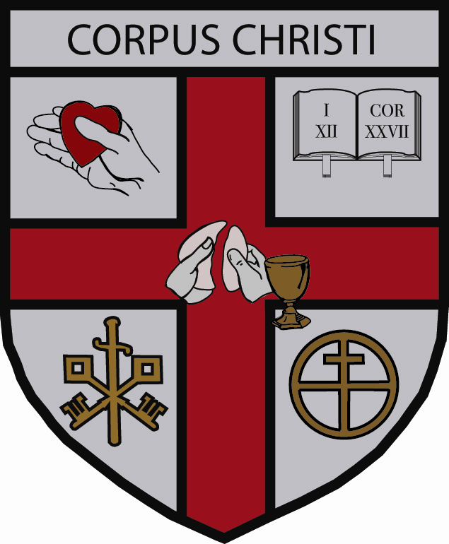
ORDER OF CORPUS CHRISTI

Annual Retreat Registration Form

May 28-31, 2024 The Jesuit Retreat Center, Cleveland, OH

Name: _______________________________________________________________________

Church: ______________________________________________________________________
Name Position

Address: _____________________________________________________________________
City State Zip Code

_____________________________________________________________________
Telephone Email

REGISTRATION AND PAYMENT MUST BE TO
BR. BRIAN BY
MAY1, 2024

Check payable to:
Order of Corpus Christi
Registration:
Retreat - $375.00: $________________

Dues - $50.00: $________________

Other ______________________: $________________

*Gift to the Order: $________________

Total Remitted: $________________

The Jesuit Retreat House has a hard deadline of May 1ST by which names of retreatants must be submitted. If you are mailing this form within a week of this date, please contact Br. Brian to ensure you are included on the registration list.

Those unable to attend should use this form for payment of dues.

*Donations and gifts to the Order of Corpus Christi are tax-deductible according to section 501(c)(3) of the Internal Revenue Code.

Return this form with a check to: Br. Brian Smith, OCC
265 Shotgun Path
Bryson City, NC 28713
Cell: (828) 301-4162
E-mail: circa325@gmail.com

Check payable to: Order of Corpus Christi

